ROCA
Developer Handoff Document
Religious Organization Calendar Application

Document Type | Engineering Handoff Reference
Source of Truth | Religious Org Calendar Design Spec v2.0
Version | 1.0
Date | August 2026
Audience | Engineering Teams (Frontend, Backend, Mobile, DevOps, QA)
Stack | React 18+ · React Native · Node.js · PostgreSQL 15+ · AWS
Related Docs | ROCA Unified Technical Design Spec v2.0

PURPOSE: This document distills the ROCA Unified Design Spec into actionable developer guidance. It is NOT a replacement for the full design spec but a practical implementation reference: sprint-ready tasks, prioritized checklists, schema DDL, API examples, TypeScript/React snippets, and infrastructure notes. Engineers should use both documents together.

Keep this doc open during implementation. Every section links back to the authoritative design spec section for deeper context.

1. Overview & Quick-Start
ROCA is a multi-tenant SaaS calendar and community management system for faith communities. This handoff doc is structured as sprint-ready sections — each maps to a development phase and contains checklists, schemas, code snippets, and acceptance criteria engineers can act on directly.

1.1 Architecture at a Glance
Layer | Technology | Deployment Target
Web Frontend | React 18+, TypeScript, Tailwind CSS | CloudFront CDN + S3
Mobile App | React Native + Expo SDK | App Store / Google Play
Backend API | Node.js + Express (or FastAPI) | AWS ECS / Lambda
Database | PostgreSQL 15+ | AWS RDS Multi-AZ
Auth | OAuth 2.0 + JWT (15-min access / 7-day refresh) | AWS Cognito or Auth0
Push Notifications | APNs (iOS) + FCM (Android) | Serverless Lambda trigger
File Storage | AWS S3 + CloudFront | Multi-region bucket
CI/CD | GitHub Actions | ECS Blue/Green deployments

1.2 Multi-Tenancy Model
Every database table carries an org_id foreign key. Multi-tenancy is enforced at two layers:
- Database layer: Row-level filtering on org_id in every query — use a query helper/middleware that automatically injects the org context from the JWT.
- Application layer: JWT claims include org_id and role. Every service method must validate both before processing.
- Never expose cross-tenant data. All multi-tenancy integration tests must assert 403/404 for cross-org token attacks. See § 12.8 Data Integrity Testing in the design spec.

1.3 RBAC Role Hierarchy
Permissions are additive — higher roles inherit lower role capabilities. Use role claim from JWT in middleware:
// Middleware example (Node.js/Express)
const ROLE_LEVELS = {
guest: 0, member: 1, volunteer: 2, leader: 3, admin: 4, pastor: 5, super_admin: 6
};

export const requireRole = (minRole: string) =>
(req: Request, res: Response, next: NextFunction) => {
const userRole = req.user?.role ?? "guest";
if (ROLE_LEVELS[userRole] < ROLE_LEVELS[minRole]) {
return res.status(403).json({ error: { code: "AUTH_002", message: "Insufficient permissions" } });
}
next();
};

// Usage on any route:
router.post("/api/v1/events", requireRole("leader"), createEvent);

2. Database Schema & DDL
Use PostgreSQL 15+. Apply schema via migration tool (Flyway or custom migration scripts). All UUIDs generated via gen_random_uuid() — no sequential IDs. Enforce org_id on every entity table.

2.1 Entity Relationship Summary
Table | Key Relationships | Purpose
organizations | Parent of all entities | Top-level tenant; multi-org/denomination
campuses | → organizations | Physical locations per org
rooms | → campuses | Bookable facilities within campus
members | → organizations | People directory + auth roles
events | → org, categories, campuses, rooms | Core calendar entries; RRULE recurrence
event_categories | → organizations | Color-coded groupings
event_registrations | → events, members | RSVP + waitlist management
liturgical_seasons | → organizations | Seasonal color theming + scripture cycles
ministry_groups | → org, campuses | Small groups, committees, choirs
group_members | → ministry_groups, members | Group roster (composite PK)
scripture_readings | → org, events | Lectionary / daily reading assignments
prayer_focuses | → organizations | Weekly / daily prayer themes
volunteer_roles | → organizations | Role definitions with min/max counts
volunteer_assignments | → events, roles, members | Volunteer scheduling per event + role
notifications | → org, events | Scheduled alerts + reminders

2.2 Full SQL DDL
Run the following migration script in order. Each CREATE TABLE references its dependencies so execute sequentially:

-- =============================================
-- ROCA — PostgreSQL 15+ Schema
-- Apply via migration tool (Flyway / custom)
-- =============================================

-- CORE TABLES
CREATE TABLE organizations (
org_id UUID PRIMARY KEY DEFAULT gen_random_uuid(),
name VARCHAR(255) NOT NULL,
denomination VARCHAR(100),
address TEXT,
city VARCHAR(100),
state VARCHAR(50),
zip VARCHAR(20),
phone VARCHAR(20),
email VARCHAR(255),
website VARCHAR(255),
timezone VARCHAR(50) NOT NULL DEFAULT 'America/New_York',
logo_url VARCHAR(500),
created_at TIMESTAMP DEFAULT NOW(),
updated_at TIMESTAMP DEFAULT NOW()
);

CREATE TABLE campuses (
campus_id UUID PRIMARY KEY DEFAULT gen_random_uuid(),
org_id UUID NOT NULL REFERENCES organizations(org_id),
name VARCHAR(255) NOT NULL,
address TEXT,
city VARCHAR(100), state VARCHAR(50), zip VARCHAR(20),
is_primary BOOLEAN DEFAULT FALSE,
accessibility_notes TEXT,
parking_info TEXT,
created_at TIMESTAMP DEFAULT NOW()
);

CREATE TABLE rooms (
room_id UUID PRIMARY KEY DEFAULT gen_random_uuid(),
campus_id UUID NOT NULL REFERENCES campuses(campus_id),
name VARCHAR(100) NOT NULL,
capacity INTEGER,
has_av_equipment BOOLEAN DEFAULT FALSE,
is_wheelchair_accessible BOOLEAN DEFAULT TRUE,
has_childcare_nearby BOOLEAN DEFAULT FALSE,
notes TEXT
);

-- PEOPLE & ROLES
CREATE TABLE members (
member_id UUID PRIMARY KEY DEFAULT gen_random_uuid(),
org_id UUID NOT NULL REFERENCES organizations(org_id),
first_name VARCHAR(100) NOT NULL,
last_name VARCHAR(100) NOT NULL,
email VARCHAR(255),
phone VARCHAR(20),
role VARCHAR(50) DEFAULT 'member',
-- pastor, admin, leader, volunteer, member, guest
avatar_url VARCHAR(500),
is_active BOOLEAN DEFAULT TRUE,
created_at TIMESTAMP DEFAULT NOW()
);

-- LITURGICAL SEASONS
CREATE TABLE liturgical_seasons (
season_id UUID PRIMARY KEY DEFAULT gen_random_uuid(),
org_id UUID NOT NULL REFERENCES organizations(org_id),
name VARCHAR(100) NOT NULL, -- Advent, Lent, Ordinary Time
color_hex VARCHAR(7),
start_date DATE NOT NULL,
end_date DATE NOT NULL,
description TEXT,
year INTEGER NOT NULL
);

-- EVENT CATEGORIES
CREATE TABLE event_categories (
category_id UUID PRIMARY KEY DEFAULT gen_random_uuid(),
org_id UUID NOT NULL REFERENCES organizations(org_id),
name VARCHAR(100) NOT NULL, -- Worship, Youth, Outreach, Admin
color_hex VARCHAR(7) NOT NULL,
icon VARCHAR(50),
sort_order INTEGER DEFAULT 0
);

-- EVENTS (core table)
CREATE TABLE events (
event_id UUID PRIMARY KEY DEFAULT gen_random_uuid(),
org_id UUID NOT NULL REFERENCES organizations(org_id),
category_id UUID REFERENCES event_categories(category_id),
campus_id UUID REFERENCES campuses(campus_id),
room_id UUID REFERENCES rooms(room_id),
title VARCHAR(255) NOT NULL,
description TEXT,
event_type VARCHAR(50) NOT NULL,
-- service, study, meeting, outreach, social, sacrament
start_datetime TIMESTAMP NOT NULL,
end_datetime TIMESTAMP NOT NULL,
is_all_day BOOLEAN DEFAULT FALSE,
is_recurring BOOLEAN DEFAULT FALSE,
recurrence_rule VARCHAR(255), -- RRULE (RFC 5545)
recurrence_end_date DATE,
max_capacity INTEGER,
requires_rsvp BOOLEAN DEFAULT FALSE,
registration_url VARCHAR(500),
livestream_url VARCHAR(500),
childcare_available BOOLEAN DEFAULT FALSE,
contact_member_id UUID REFERENCES members(member_id),
visibility VARCHAR(20) DEFAULT 'public',
-- public, members_only, leaders_only
status VARCHAR(20) DEFAULT 'active',
-- active, cancelled, postponed
cancellation_reason TEXT,
created_by UUID REFERENCES members(member_id),
created_at TIMESTAMP DEFAULT NOW(),
updated_at TIMESTAMP DEFAULT NOW()
);

-- RSVP / REGISTRATIONS
CREATE TABLE event_registrations (
registration_id UUID PRIMARY KEY DEFAULT gen_random_uuid(),
event_id UUID NOT NULL REFERENCES events(event_id),
member_id UUID REFERENCES members(member_id),
guest_name VARCHAR(200),
guest_email VARCHAR(255),
party_size INTEGER DEFAULT 1,
status VARCHAR(20) DEFAULT 'registered',
-- registered, waitlisted, cancelled
notes TEXT,
registered_at TIMESTAMP DEFAULT NOW()
);

-- MINISTRY GROUPS
CREATE TABLE ministry_groups (
group_id UUID PRIMARY KEY DEFAULT gen_random_uuid(),
org_id UUID NOT NULL REFERENCES organizations(org_id),
name VARCHAR(255) NOT NULL,
description TEXT,
group_type VARCHAR(50), -- small_group, ministry, committee, choir
leader_member_id UUID REFERENCES members(member_id),
meeting_day VARCHAR(10),
meeting_time TIME,
campus_id UUID REFERENCES campuses(campus_id),
is_active BOOLEAN DEFAULT TRUE
);

CREATE TABLE group_members (
group_id UUID NOT NULL REFERENCES ministry_groups(group_id),
member_id UUID NOT NULL REFERENCES members(member_id),
role VARCHAR(50) DEFAULT 'member', -- leader, co-leader, member
joined_at TIMESTAMP DEFAULT NOW(),
PRIMARY KEY (group_id, member_id)
);

-- SPIRITUAL CONTENT
CREATE TABLE scripture_readings (
reading_id UUID PRIMARY KEY DEFAULT gen_random_uuid(),
org_id UUID NOT NULL REFERENCES organizations(org_id),
event_id UUID REFERENCES events(event_id),
reading_date DATE NOT NULL,
reading_type VARCHAR(50), -- first_reading, psalm, gospel, epistle
reference VARCHAR(100) NOT NULL, -- e.g. "John 3:16-21"
text_content TEXT,
sort_order INTEGER DEFAULT 0
);

CREATE TABLE prayer_focuses (
prayer_id UUID PRIMARY KEY DEFAULT gen_random_uuid(),
org_id UUID NOT NULL REFERENCES organizations(org_id),
title VARCHAR(255) NOT NULL,
description TEXT,
start_date DATE NOT NULL,
end_date DATE NOT NULL,
prayer_type VARCHAR(50) -- weekly, daily, special
);

-- VOLUNTEER SCHEDULING
CREATE TABLE volunteer_roles (
role_id UUID PRIMARY KEY DEFAULT gen_random_uuid(),
org_id UUID NOT NULL REFERENCES organizations(org_id),
name VARCHAR(100) NOT NULL, -- Greeter, Usher, Sound Tech
description TEXT,
min_volunteers INTEGER DEFAULT 1,
max_volunteers INTEGER
);

CREATE TABLE volunteer_assignments (
assignment_id UUID PRIMARY KEY DEFAULT gen_random_uuid(),
event_id UUID NOT NULL REFERENCES events(event_id),
role_id UUID NOT NULL REFERENCES volunteer_roles(role_id),
member_id UUID NOT NULL REFERENCES members(member_id),
status VARCHAR(20) DEFAULT 'assigned',
-- assigned, confirmed, declined, swapped
notes TEXT,
assigned_at TIMESTAMP DEFAULT NOW()
);

-- NOTIFICATIONS
CREATE TABLE notifications (
notification_id UUID PRIMARY KEY DEFAULT gen_random_uuid(),
org_id UUID NOT NULL REFERENCES organizations(org_id),
event_id UUID REFERENCES events(event_id),
title VARCHAR(255) NOT NULL,
message TEXT NOT NULL,
notification_type VARCHAR(50),
-- reminder, cancellation, update, weather_alert
send_at TIMESTAMP,
sent BOOLEAN DEFAULT FALSE,
created_at TIMESTAMP DEFAULT NOW()
);

-- PERFORMANCE INDEXES
CREATE INDEX idx_events_org_date ON events(org_id, start_datetime);
CREATE INDEX idx_events_category ON events(category_id);
CREATE INDEX idx_events_campus ON events(campus_id);
CREATE INDEX idx_events_recurring ON events(is_recurring) WHERE is_recurring = TRUE;
CREATE INDEX idx_registrations_event ON event_registrations(event_id);
CREATE INDEX idx_liturgical_dates ON liturgical_seasons(org_id, start_date, end_date);
CREATE INDEX idx_volunteer_event ON volunteer_assignments(event_id);
CREATE INDEX idx_scripture_date ON scripture_readings(org_id, reading_date);

2.3 Key DDL Implementation Notes
- Timestamps: All stored as UTC TIMESTAMP. Apply DEFAULT NOW() on created_at/updated_at. Display in org timezone using AT TIME ZONE org.timezone.
- Soft deletes: Use status ('active'/'cancelled'/'postponed') on events and is_active on members. Never physically delete operational records.
- Partial index on is_recurring: Critical for performance. The calendar view must expand recurring series — this partial index ensures only the ~20% of events that are recurring are scanned.
- RRULE format: Store as VARCHAR(255). Parse at application layer using rrule.js (web/Node) or python-dateutil (Python). See § 4 for RRULE examples.
- Capacity enforcement: Use SELECT ... FOR UPDATE or optimistic locking when registering to prevent race conditions at capacity boundary. See § 2.8 Data Integrity tests.

3. API Reference
Base URL: /api/v1/ • Auth: Authorization: Bearer <JWT> • Content-Type: application/json

3.1 Standard Response Envelope
// Success (single resource)
{ "data": { ...resource }, "meta": { "request_id": "uuid" } }

// Success (list)
{ "data": [...], "meta": { "total": 42, "page": 1, "limit": 20, "total_pages": 3 } }

// Error
{ "error": { "code": "EVENT_002", "message": "Scheduling conflict detected",
"details": [...], "request_id": "uuid" } }

3.2 Key Endpoint Groups (75+ total)
Method | Path | Access | Description
AUTH
POST | /api/v1/auth/login | PUBLIC | Get JWT + refresh token
POST | /api/v1/auth/refresh | Auth | Exchange refresh for new access token
POST | /api/v1/auth/register | PUBLIC | Register new member (pending approval)
EVENTS
GET | /api/v1/events | guest/member+ | List with date range, campus, category filters
POST | /api/v1/events | leader+ | Create event (4-step wizard payload)
GET | /api/v1/events/{id} | visibility-based | Full detail: vols, RSVPs, scripture
PUT | /api/v1/events/{id} | leader+ | Update; update_scope param for recurring
POST | /api/v1/events/{id}/cancel | admin, pastor | Cancel + notify registrants
POST | /api/v1/events/conflicts | leader+ | Pre-flight conflict check
REGISTRATIONS
POST | /api/v1/events/{id}/registrations | member+ | RSVP; auto-waitlists at capacity
DELETE | /api/v1/events/{id}/registrations/{rid} | self/admin | Cancel; auto-promotes waitlist #1
VOLUNTEERS
GET | /api/v1/volunteer-assignments/gaps | leader+ | Find unfilled positions
POST | /api/v1/volunteer-assignments/auto-schedule | admin, pastor | Auto-generate schedule draft
LITURGICAL
GET | /api/v1/liturgical-seasons/current | PUBLIC | Current season name, color, week #
POST | /api/v1/scripture-readings/import | pastor | Bulk import RCL/Catholic/Lutheran lectionary

3.3 JSON API Examples

3.3.1 Create Event
// POST /api/v1/events
// Headers: Authorization: Bearer <leader-jwt>
{
"title": "Fall Festival & Potluck",
"category_id": "uuid-all-church-category",
"campus_id": "uuid-main-campus",
"room_id": "uuid-fellowship-hall",
"event_type": "social",
"start_datetime": "2026-09-28T16:00:00Z",
"end_datetime": "2026-09-28T20:00:00Z",
"is_recurring": false,
"max_capacity": 200,
"requires_rsvp": true,
"childcare_available": true,
"visibility": "public",
"contact_member_id": "uuid-pastor-kim"
}

// 201 Response
{
"data": {
"event_id": "a1b2c3d4-...",
"title": "Fall Festival & Potluck",
"status": "active",
"spots_remaining": 200
},
"meta": { "request_id": "req_abc123" }
}

3.3.2 RSVP with Auto-Waitlist
// POST /api/v1/events/{event_id}/registrations
{
"party_size": 2,
"notes": "Bringing vegetarian dish"
}

// 201 Response — spot available
{ "data": { "registration_id": "uuid", "status": "registered" } }

// 201 Response — at capacity, auto-waitlisted
{ "data": { "registration_id": "uuid", "status": "waitlisted", "queue_position": 3 } }

// 409 Error — already registered
{ "error": { "code": "REG_002", "message": "Already registered for this event" } }

3.3.3 Recurring Event (RRULE)
// POST /api/v1/events — Weekly Sunday Worship
{
"title": "Sunday Worship (Traditional)",
"event_type": "service",
"start_datetime": "2026-09-07T09:00:00Z",
"end_datetime": "2026-09-07T10:15:00Z",
"is_recurring": true,
"recurrence_rule": "FREQ=WEEKLY;BYDAY=SU",
"recurrence_end_date": "2026-12-31",
"visibility": "public"
}

// Edit scope options (PUT request param):
// "update_scope": "this_instance" | "this_and_future" | "all_instances"

// Common RRULE patterns:
// Every Sunday: FREQ=WEEKLY;BYDAY=SU
// First Wednesday/month: FREQ=MONTHLY;BYDAY=1WE
// Daily 40 days (Lent): FREQ=DAILY;COUNT=40
// Bi-weekly Tuesday: FREQ=WEEKLY;INTERVAL=2;BYDAY=TU
// Last Sunday/month: FREQ=MONTHLY;BYDAY=-1SU

3.3.4 Volunteer Gap Detection
// GET /api/v1/volunteer-assignments/gaps?start_date=2026-08-24&end_date=2026-09-07
//
// 200 Response:
{
"data": {
"gaps": [
{
"event_id": "uuid-sunday-worship",
"event_title": "Sunday Worship (Traditional)",
"event_datetime": "2026-08-24T09:00:00Z",
"role_id": "uuid-nursery",
"role_name": "Nursery",
"needed": 2,
"assigned": 1,
"shortfall": 1
}
],
"total_gaps": 1
}
}

3.4 Error Codes Reference
Code | HTTP | Description & When It Fires
AUTH_001 | 401 | Invalid or expired access token
AUTH_002 | 403 | Insufficient role permissions for this action
AUTH_003 | 403 | Resource not visible at requesting access level
EVENT_001 | 404 | Event not found or not accessible by this org
EVENT_002 | 409 | Room or time conflict detected during event creation/update
EVENT_003 | 422 | Invalid RRULE recurrence rule string
REG_001 | 409 | Event at max capacity (auto-waitlists instead in most flows)
REG_002 | 409 | Member already registered for this event
VOL_001 | 409 | Volunteer already assigned to this role for this event
VOL_002 | 409 | max_volunteers count reached for this role
ROOM_001 | 409 | Room already booked for overlapping time slot
GENERAL_002 | 429 | Rate limit exceeded — see X-RateLimit-Reset header

3.5 Rate Limits
Role Tier | Limit | Response Headers
guest | 30 req/min | X-RateLimit-Limit, X-RateLimit-Remaining, X-RateLimit-Reset
member | 100 req/min | Standard headers
leader | 200 req/min | Standard headers
admin / pastor | 500 req/min | Standard headers
Webhooks (outbound) | 1,000 events/min | Exponential backoff on delivery failure

4. TypeScript & React Implementation Snippets
Production-ready reference implementations. Adapt namespaces and import paths to your project structure.

4.1 Core Type Definitions
// types/roca.ts

export type UserRole = "guest" | "member" | "volunteer" | "leader" | "admin" | "pastor" | "super_admin";
export type EventType = "service" | "study" | "meeting" | "outreach" | "social" | "sacrament";
export type EventStatus = "active" | "cancelled" | "postponed";
export type EventVisibility = "public" | "members_only" | "leaders_only";
export type AssignmentStatus = "assigned" | "confirmed" | "declined" | "swapped";
export type RegistrationStatus = "registered" | "waitlisted" | "cancelled";

export interface JWTClaims {
sub: string; // member_id
org_id: string;
role: UserRole;
iat: number;
exp: number;
}

export interface Event {
event_id: string;
org_id: string;
title: string;
event_type: EventType;
start_datetime: string; // ISO 8601 UTC
end_datetime: string;
is_recurring: boolean;
recurrence_rule?: string; // RFC 5545 RRULE
visibility: EventVisibility;
status: EventStatus;
max_capacity?: number;
spots_remaining?: number;
requires_rsvp: boolean;
childcare_available: boolean;
livestream_url?: string;
}

export interface LiturgicalSeason {
season_id: string;
name: string;
color_hex: string; // e.g. "#4A235A" for Advent
start_date: string;
end_date: string;
week_number: number;
}

export interface VolunteerGap {
event_id: string;
event_title: string;
event_datetime: string;
role_id: string;
role_name: string;
needed: number;
assigned: number;
shortfall: number;
}

4.2 API Client with JWT Auto-Refresh
// lib/apiClient.ts
import axios, { AxiosInstance } from "axios";

let accessToken: string | null = null;

export const apiClient: AxiosInstance = axios.create({
baseURL: process.env.NEXT_PUBLIC_API_URL,
headers: { "Content-Type": "application/json" },
});

// Request interceptor — attach JWT
apiClient.interceptors.request.use((config) => {
if (accessToken) config.headers.Authorization = `Bearer ${accessToken}`;
return config;
});

// Response interceptor — silent refresh on 401
apiClient.interceptors.response.use(
(response) => response,
async (error) => {
if (error.response?.status === 401 && !error.config._retry) {
error.config._retry = true;
const { data } = await axios.post("/api/v1/auth/refresh",
{ refresh_token: localStorage.getItem("refresh_token") });
accessToken = data.access_token;
error.config.headers.Authorization = `Bearer ${accessToken}`;
return apiClient(error.config);
}
return Promise.reject(error);
}
);

4.3 Calendar Events Hook (React Query)
// hooks/useEvents.ts
import { useQuery } from "@tanstack/react-query";
import { apiClient } from "@/lib/apiClient";
import type { Event } from "@/types/roca";

interface UseEventsParams {
startDate: string; // YYYY-MM-DD
endDate: string;
campusId?: string;
categoryId?: string;
}

export function useEvents({ startDate, endDate, campusId, categoryId }: UseEventsParams) {
return useQuery({
queryKey: ["events", startDate, endDate, campusId, categoryId],
queryFn: async () => {
const params = new URLSearchParams({
start_date: startDate, end_date: endDate,
...(campusId && { campus_id: campusId }),
...(categoryId && { category_id: categoryId }),
});
const { data } = await apiClient.get(`/api/v1/events?${params}`);
return data.data as Event[];
},
staleTime: 5 * 60 * 1000, // 5 minutes
gcTime: 10 * 60 * 1000,
});
}

4.4 Liturgical Season Banner Component
// components/LiturgicalBanner.tsx
import { useQuery } from "@tanstack/react-query";
import { apiClient } from "@/lib/apiClient";
import type { LiturgicalSeason } from "@/types/roca";

export function LiturgicalBanner() {
const { data: season } = useQuery({
queryKey: ["liturgical-season-current"],
queryFn: async () => {
const { data } = await apiClient.get("/api/v1/liturgical-seasons/current");
return data.data as LiturgicalSeason;
},
staleTime: 24 * 60 * 60 * 1000, // refresh daily
});

if (!season) return null;

return (
<div
className="rounded-lg px-4 py-3 text-white"
style={{ backgroundColor: season.color_hex }}
role="banner"
aria-label={`Liturgical season: ${season.name}`}
>
<span className="font-semibold">{season.name}</span>
<span className="mx-2 opacity-70">&#183;</span>
<span>Week {season.week_number}</span>
</div>
);
}

4.5 RBAC Hook (Permission Guard)
// hooks/usePermission.ts
import { useAuth } from "@/contexts/AuthContext";
import type { UserRole } from "@/types/roca";

const ROLE_LEVELS: Record<UserRole, number> = {
guest: 0, member: 1, volunteer: 2,
leader: 3, admin: 4, pastor: 5, super_admin: 6
};

export function usePermission(minRole: UserRole): boolean {
const { user } = useAuth();
const userLevel = ROLE_LEVELS[user?.role ?? "guest"];
return userLevel >= ROLE_LEVELS[minRole];
}

// Usage in any component:
// const canCreateEvent = usePermission("leader");
// const canManageMembers = usePermission("admin");

// PermissionGate wrapper:
export function PermissionGate({
minRole, children, fallback = null
}: { minRole: UserRole; children: React.ReactNode; fallback?: React.ReactNode }) {
const allowed = usePermission(minRole);
return allowed ? <>{children}</> : <>{fallback}</>;
}

4.6 Volunteer Gap Alert Component
// components/VolunteerGapAlert.tsx
import { useQuery } from "@tanstack/react-query";
import { apiClient } from "@/lib/apiClient";
import type { VolunteerGap } from "@/types/roca";

export function VolunteerGapAlert({ startDate, endDate }: { startDate: string; endDate: string }) {
const { data: gaps } = useQuery({
queryKey: ["volunteer-gaps", startDate, endDate],
queryFn: async () => {
const { data } = await apiClient.get(
`/api/v1/volunteer-assignments/gaps?start_date=${startDate}&end_date=${endDate}`
);
return data.data.gaps as VolunteerGap[];
},
});

if (!gaps || gaps.length === 0) return null;

return (
<div className="rounded border-l-4 border-amber-500 bg-amber-50 p-3" role="alert">
<p className="font-semibold text-amber-800">
⚠️ {gaps.length} volunteer {gaps.length === 1 ? "gap" : "gaps"} need filling
</p>
<ul className="mt-1 text-sm text-amber-700">
{gaps.map(gap => (
<li key={`${gap.event_id}-${gap.role_id}`}>
{gap.role_name} — {gap.event_title} ({gap.shortfall} needed)
</li>
))}
</ul>
</div>
);
}

5. Design Mockup References
High-fidelity mockups approved by design. Use as pixel-perfect reference during implementation. Mockups are sourced from the ROCA Unified Technical Design Specification § 6–7.

5.1 Web Dashboard — Home Screen
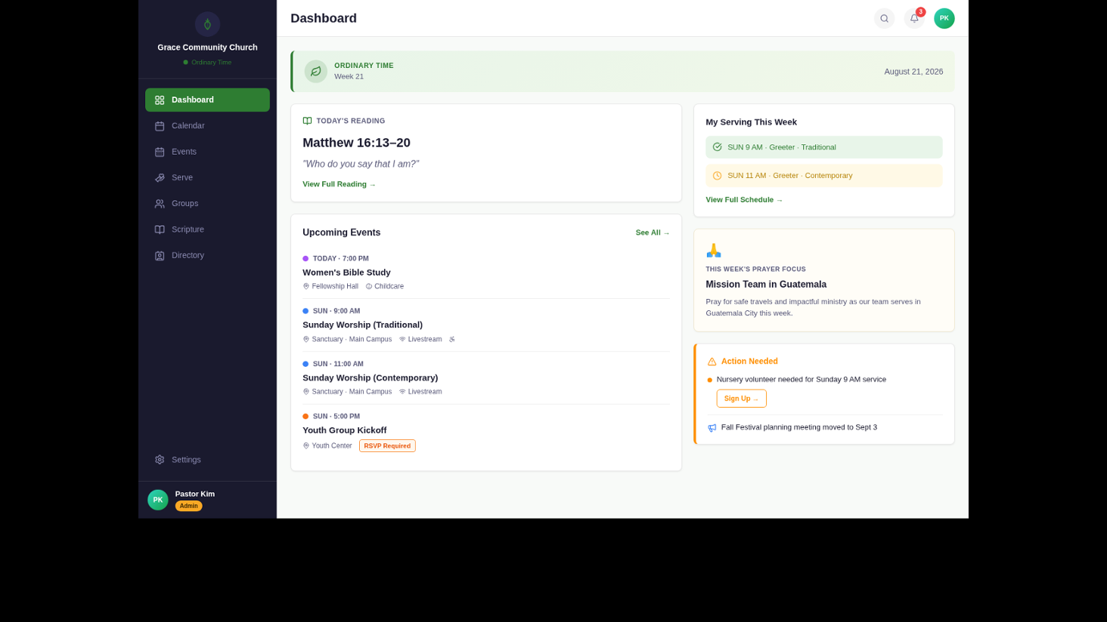
Figure 1: Dashboard / Home — Web UI (Ordinary Time · August 2026)
Key implementation notes for this screen:
• Liturgical season banner: GET /api/v1/liturgical-seasons/current (PUBLIC, cache 24h)
• Sidebar category checkboxes: persist filter state in localStorage, re-fetch on change
• Upcoming events: GET /api/v1/events/upcoming?days=7 — show category color dot per category.color_hex
• Volunteer alerts: GET /api/v1/volunteer-assignments/gaps — poll every 5min if role >= leader
• Prayer focus: GET /api/v1/prayer-focuses/current (PUBLIC, cache 24h)

5.2 Calendar View — Monthly
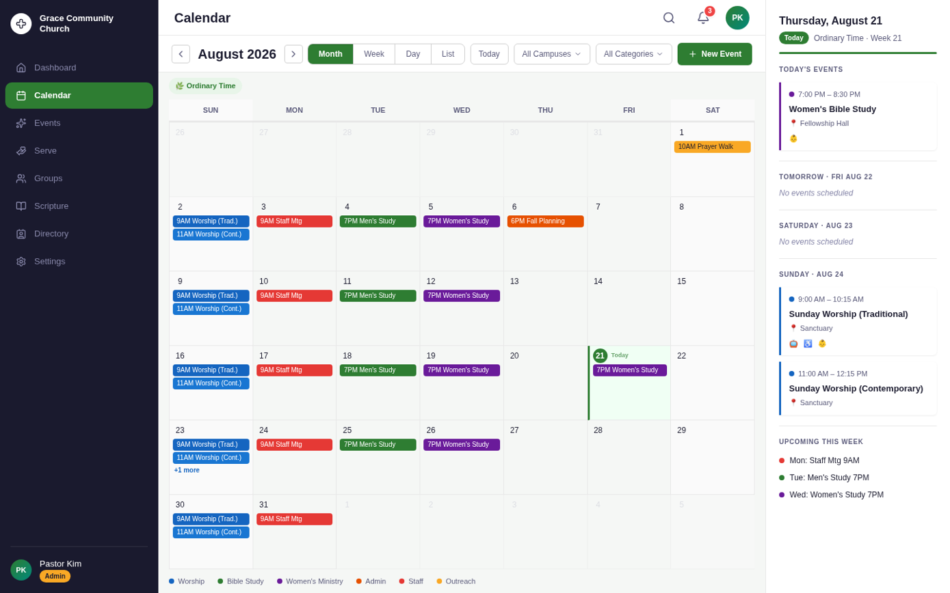
Figure 2: Calendar View (Month) — August 2026
Key implementation notes for this screen:
• Query: GET /api/v1/events?start_date=YYYY-MM-01&end_date=YYYY-MM-31&campus_id=...&category_id=...
• Render event pills with category.color_hex as background; white text on dark, dark text on light
• Today cell: highlight with green circle, apply bg-green-50 tint
• Overflow: show "+N more" link; clicking opens a popover/bottom sheet with all events for that day
• View toggle (Month/Week/Day/List): use URL param ?view=month|week|day|list for deep-link support

5.3 Event Flyout Detail Panel
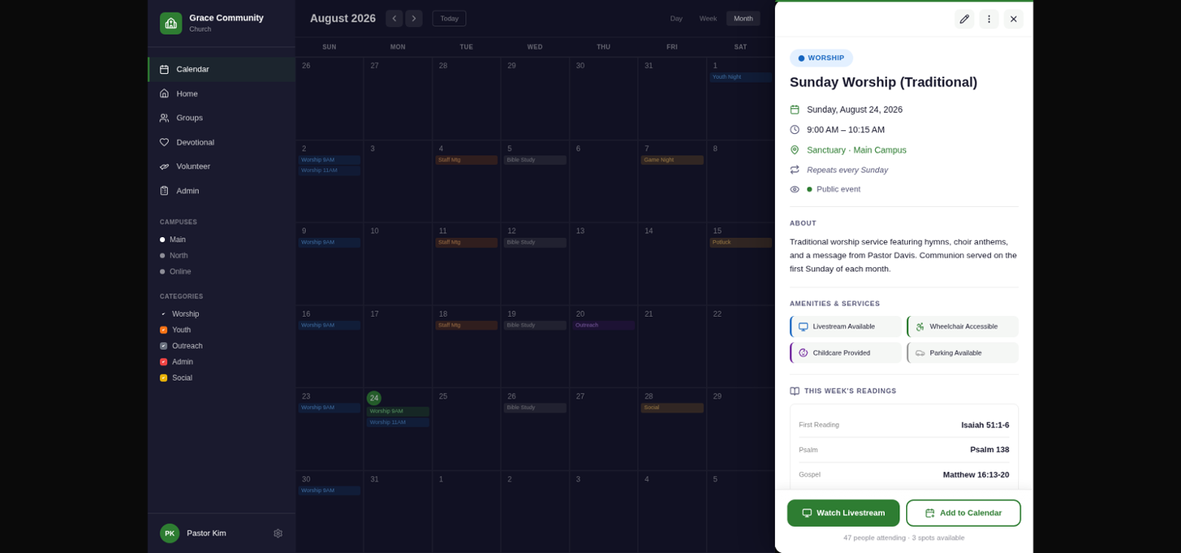
Figure 3: Event Detail Flyout Panel — Sunday Worship (Traditional)
Key implementation notes for this screen:
• Data: GET /api/v1/events/{event_id} — includes registrations_count, volunteers[], scripture_readings[]
• Nursery OPEN gap (⚠️): check volunteers where role_name="Nursery" and count < volunteer_roles.min_volunteers
• "Volunteer for Nursery →" CTA: calls POST /api/v1/volunteer-assignments with current member_id
• "Watch Live": open livestream_url in new tab; only render if livestream_url is non-null
• Flyout animation: Framer Motion slide-in from right, backdrop blur on calendar grid behind

5.4 Volunteer Schedule View
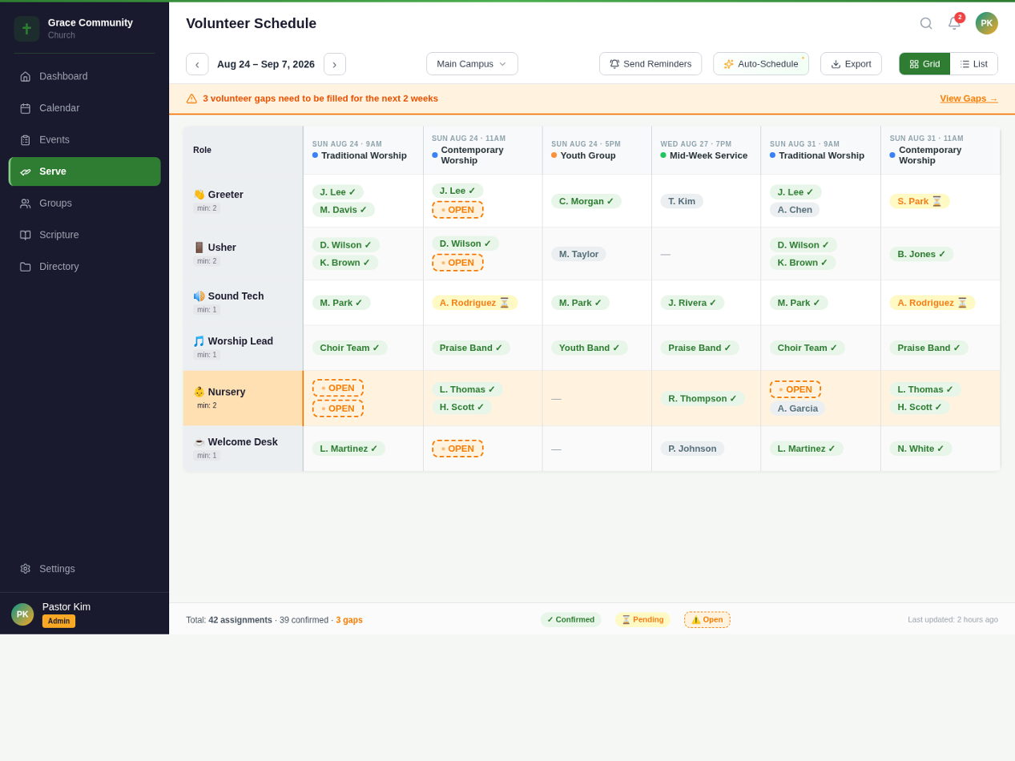
Figure 4: Volunteer Schedule View — Week of August 24, 2026

5.5 Event Creation Modal (4-Step Wizard)
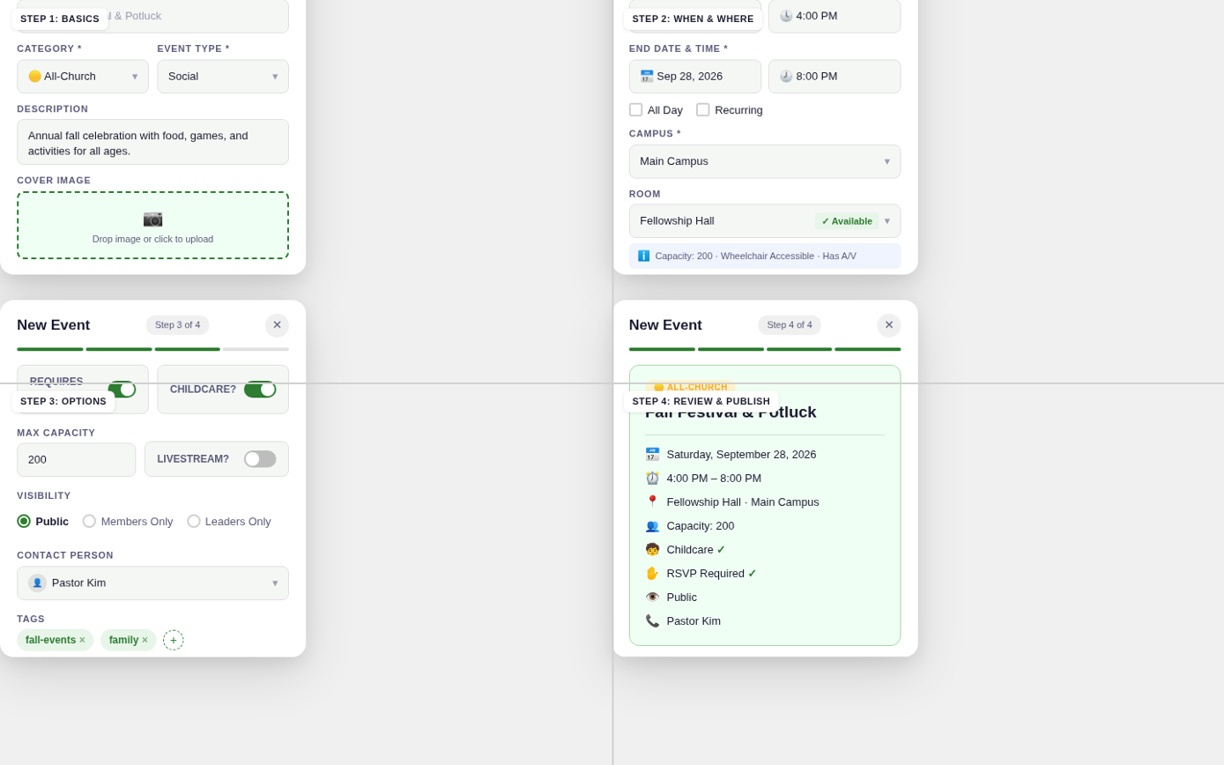
Figure 5: Event Creation Wizard (4 Steps) — Web Modal

5.6 Mobile Screens — Core Screens (Home, Calendar, Event Detail)
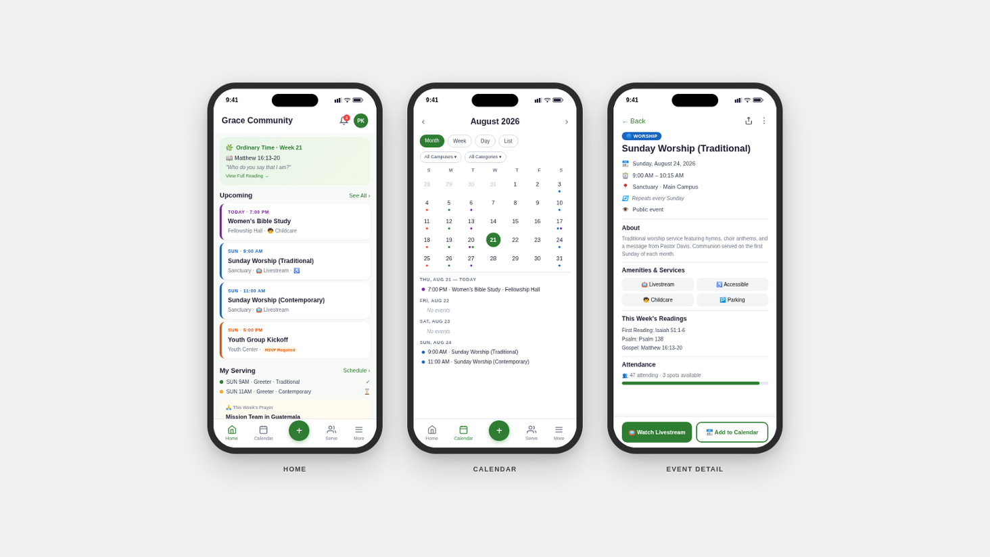
Figure 6: Mobile Core Screens — Home / Calendar / Event Detail (iOS)

5.7 Mobile Screens — Serve / Volunteer Hub
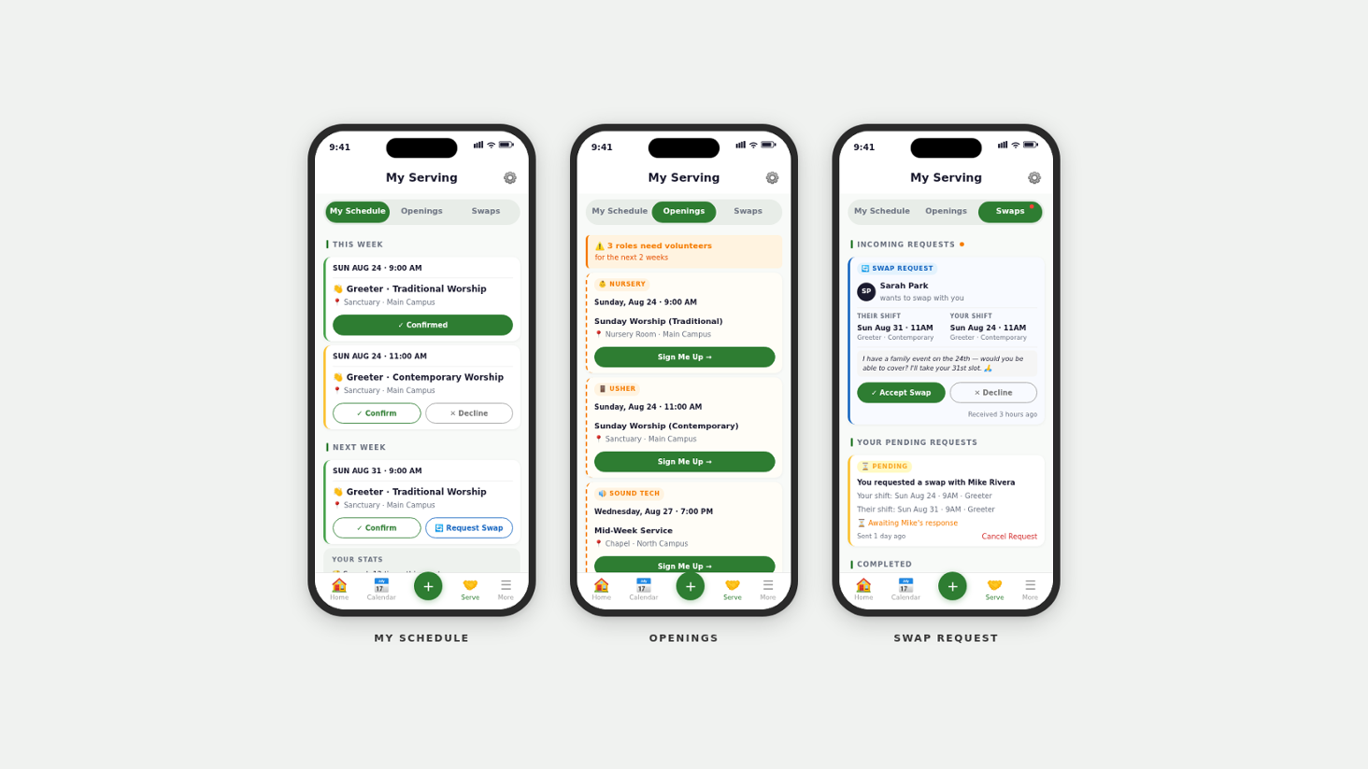
Figure 7: Mobile Serve Screens — My Schedule / Openings / Swaps (iOS)

5.8 Mobile Screens — Event Creation & Notifications
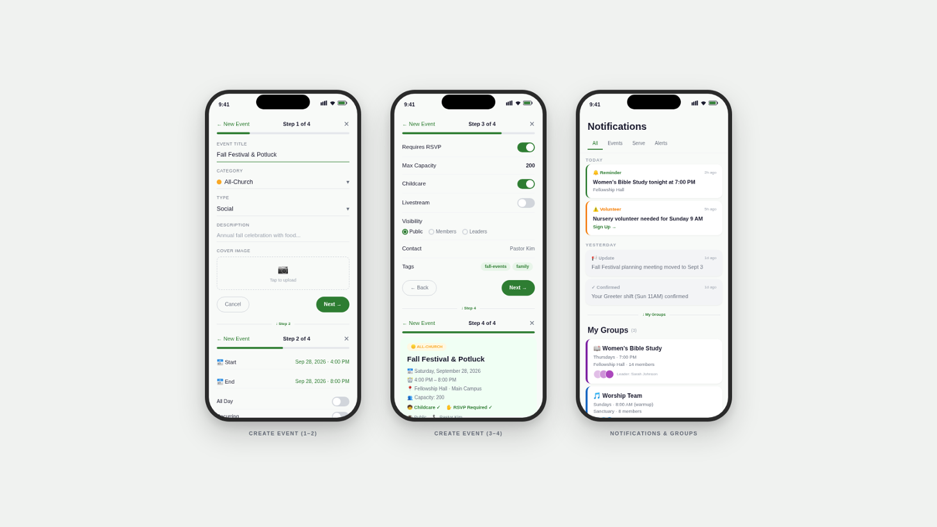
Figure 8: Mobile Event Creation Wizard + Notifications Center (iOS)

6. Sprint Plan & Implementation Checklists
Recommended 4-sprint delivery plan for MVP (v1.0). Each sprint is 2 weeks. All checklists are acceptance-criteria-ready.

Sprint 1: Foundation (Weeks 1–2)
Sprint 1 Goal
Database, Auth, Core API, CI/CD Pipeline operational

Database
- Apply full SQL DDL via Flyway migration scripts (see § 2.2)
- Seed organizations table with 2 test orgs (Grace Community + St. Francis)
- Seed campuses (3 per org), rooms (8 per campus), members (150 per org, all roles)
- Validate all FK constraints and partial index on is_recurring
- Confirm org_id isolation: cross-org query returns zero results

Authentication
- Implement POST /api/v1/auth/register and /login
- JWT access token: 15-min TTL, signed RS256; refresh token: 7-day, stored httpOnly cookie
- requireRole() middleware rejects with AUTH_002 on insufficient role
- POST /api/v1/auth/refresh: silent refresh; force logout on expired refresh token
- Biometric auth integration in React Native (iOS: Face ID, Android: Fingerprint)

Core API
- GET /api/v1/organizations, campuses, rooms (member+)
- GET/POST /api/v1/members (CRUD with RBAC)
- GET/POST/PUT/DELETE /api/v1/event-categories
- GET /api/v1/liturgical-seasons/current (PUBLIC, returns color_hex, week_number)

CI/CD
- GitHub Actions pipeline: lint → unit tests → SAST (Semgrep) → integration tests
- Ephemeral test DB spun up per PR, seeded, torn down post-run
- Coverage gates enforced: 80% line minimum, 90%+ on service layer
- Docker build + push to ECR; staging deploy on merge to main

Sprint 2: Events & Calendar (Weeks 3–4)
Sprint 2 Goal
Full event lifecycle, RRULE recurrence, RSVP with waitlist, web calendar view operational

Events API
- GET /api/v1/events with date range, campus_id, category_id filters
- POST /api/v1/events: validate RRULE (EVENT_003 on invalid), room conflict check (EVENT_002)
- PUT /api/v1/events/{id} with update_scope: this_instance | this_and_future | all_instances
- POST /api/v1/events/{id}/cancel: set status=cancelled, cascade notifications
- POST /api/v1/events/conflicts: pre-flight conflict detection endpoint
- GET /api/v1/events/upcoming?days=7 for dashboard convenience
- GET /api/v1/events/export/ical: RFC 5545 iCal export

RSVP & Registrations
- POST /api/v1/events/{id}/registrations: auto-waitlist when max_capacity reached
- DELETE registration: auto-promote first waitlisted member; send promotion notification
- Concurrent RSVP race condition test: 10 simultaneous RSVPs for last 1 spot
- GET registrations/export as CSV (leader+)

Web Frontend — Calendar
- Monthly calendar grid (Month/Week/Day/List toggle) — see Figure 2
- Event pills with category.color_hex; "+N more" overflow handling
- Sidebar campus + category filters; persist state in localStorage
- Event flyout slide-in panel with full detail — see Figure 3
- Dashboard home screen with liturgical banner + upcoming events — see Figure 1
- "Watch Live" CTA renders only when livestream_url is non-null

Sprint 3: Volunteers, Mobile, Notifications (Weeks 5–6)
Sprint 3 Goal
Volunteer scheduling, gap alerts, mobile app (React Native), push notifications

Volunteer Management
- CRUD for volunteer_roles with min/max_volunteers enforcement
- POST /api/v1/volunteer-assignments: assign + push notification to volunteer
- PUT assignment: confirm, decline, swap_request status transitions
- GET /api/v1/volunteer-assignments/gaps: expose shortfall per role/event
- POST auto-schedule: round_robin | weighted | preference_based strategies
- Admin review flow: draft → approve & publish schedule
- Volunteer schedule matrix view — see Figure 4

Mobile App (React Native)
- 5-tab navigation: Home / Calendar / Quick-Add (+) / Serve / More
- Dashboard screen: liturgical banner, scripture, upcoming events — see Figure 6
- Calendar month view: swipe gesture L/R for month navigation
- Event detail full screen with sticky action bar — see Figure 6
- Serve tab: My Schedule (confirm/decline) + Openings + Swap Requests — see Figure 7
- 4-step Event Creation wizard on mobile — see Figure 8
- Offline mode: 24h cache, queue-and-sync writes, "Offline · Changes will sync" banner

Push Notifications
- APNs (iOS) + FCM (Android) integration
- 9 notification types: reminder, volunteer_assigned, gap_alert, cancellation, rsvp_confirm, swap_request, new_event, weekly_digest, scripture_of_the_day
- Deep link routing: roca://event/{id}, roca://serve/schedule, roca://serve/openings
- Quiet hours: respect user notification preference settings
- < 5 seconds delivery from trigger (APNs/FCM SLA dependent)

Sprint 4: Scripture, Groups, Analytics, Hardening (Weeks 7–8)
Sprint 4 Goal
Scripture/lectionary, ministry groups, analytics endpoints, security hardening, v1.0 release

Scripture & Liturgical Content
- GET /api/v1/scripture-readings/today (PUBLIC)
- POST /api/v1/scripture-readings/import: bulk RCL/Catholic/Lutheran import for a year/cycle
- CRUD prayer_focuses with current endpoint
- Liturgical season auto-generate by denomination template (catholic, lutheran, anglican)
- Season change webhook: fire season.changed when current season transitions

Ministry Groups
- CRUD for ministry_groups and group_members
- My Groups screen in mobile — see Figure 8
- Group detail: member roster + upcoming events

Analytics & Search
- GET /api/v1/analytics/attendance by event_type and granularity (admin+)
- GET /api/v1/analytics/volunteers: confirmation_rate, gap_rate, top_volunteers
- GET /api/v1/search: full-text across events, groups, members (results filtered by role)

Security & Hardening
- OWASP Top 10: parameterized queries, XSS prevention, CSRF tokens
- Rate limiting enforced per role tier (see § 3.5)
- TLS 1.3 on all endpoints; AES-256 at rest (RDS + S3)
- RBAC boundary tests: all 7 roles × 12 resource types (see design spec § 12.5)
- Multi-tenant isolation: cross-org token attack returns 403/404
- Quarterly external pentest scheduled

7. Performance & Infrastructure Specifications

7.1 Performance Targets (Enforced as CI/CD Gates)
Metric | Target | Measurement Method
Dashboard load (web) | < 1.5s p95 LCP | Lighthouse CI on every merge to main
Calendar month render | < 800ms | k6 load test with 500 concurrent users
API response (p95) | < 300ms | k6 — enforced as pass/fail gate
Mobile cold start | < 2 seconds | Detox + XCTest / Espresso on device
Push notification delivery | < 5s from trigger | Custom harness + APNs/FCM latency logging
Calendar query (100K events) | < 50ms (index scan) | EXPLAIN ANALYZE with pgbench
iCal export (12 months) | < 2 seconds | k6 endpoint test

7.2 AWS Infrastructure
# Infrastructure overview (Terraform-managed)

# Web Frontend
S3 bucket (static assets) + CloudFront CDN
• HTTPS-only; HSTS header enforced
• Cache-Control: immutable for hashed assets

# API (Node.js/Express)
ECS Fargate (auto-scaling, 2–10 tasks)
• Task CPU: 0.5 vCPU, Memory: 1GB (scale up under load)
• Application Load Balancer with health check /api/v1/health
• Blue/Green deployment via CodeDeploy; instant rollback

# Database
RDS PostgreSQL 15 Multi-AZ (db.t3.medium minimum)
• Automatic failover < 60s
• Daily full backup + hourly incremental; 30-day retention
• RPO < 1 hour | RTO < 4 hours
• AES-256 encryption at rest

# Push Notifications
Lambda function triggered by SQS queue
• SNS topic per org for fan-out delivery
• APNs HTTP/2 + FCM v1 API
• Exponential backoff: 1s, 2s, 4s, 8s (max 3 retries)

# File Storage
S3 multi-region bucket for org logos, event images
• Pre-signed upload URLs (never expose S3 credentials to client)
• CloudFront for delivery; 30-day cache TTL

# Secrets Management
AWS Secrets Manager for DB creds, JWT keys, APNs certs
• Automatic rotation every 90 days
• Never hardcode secrets; GitLeaks scan on every commit

7.3 Availability & Reliability
Requirement | Specification
Uptime SLA | 99.9% (≈8.7 hours/year downtime; excludes planned maintenance windows)
DB Failover | Multi-AZ RDS; automatic failover < 60 seconds; no application code change required
API Scaling | ECS auto-scaling; health checks every 30s; scale-out at 70% CPU
Circuit Breaker | All external calls (APNs, FCM, S3) wrapped in circuit breaker; 5 failures = open; retry after 30s
RPO | < 1 hour (hourly incremental backups to S3 with cross-region replication)
RTO | < 4 hours (automated restore runbook; annual DR drill required)

7.4 Security Checklist
- Transport: TLS 1.3 enforced on all endpoints; HTTPS redirect; HSTS header (max-age=31536000)
- At-rest: AES-256 on RDS and S3; Secrets Manager for credentials and private keys
- Auth tokens: JWT RS256; 15-min access token; 7-day refresh stored httpOnly/Secure cookie; revocation via refresh token DB table
- Passwords: bcrypt cost factor 12 minimum; never logged or returned in API responses
- SQL injection: Parameterized queries throughout; ORM with named params; no string concatenation in SQL
- XSS: Output encoding on all user-generated content; CSP header enforced; React JSX prevents injection by default
- CORS: Allowlist of approved origins only; OPTIONS preflight required; credentials mode: include
- RBAC: Role enforced at route middleware (requireRole) AND service layer; never trust client-supplied role claims
- Audit logging: All admin/pastor actions on member data logged with actor_id, action, before/after, timestamp
- Secrets: GitLeaks + TruffleHog scan on every commit; never commit .env files

8. Testing Quick Reference
Full testing strategy in Design Spec § 12. This section provides engineer-ready reference for daily development.

8.1 Coverage Targets
Module / Layer | Coverage Target | Key Test Areas
Service Layer (business logic) | 90% line | RBAC checks, recurrence expansion, volunteer gap detection
Auth & Token Logic | 95% line | JWT generation/validation, refresh flow, role extraction
Recurrence Engine (RRULE) | 95% line | RRULE parsing, DST handling, exception modification
API Route Handlers | 80% line | Request validation, response shaping, error codes
React Web Components | 80% line | Render, prop handling, user interactions, RBAC guards
React Native Components | 80% line | Render output, gesture handlers, offline behavior
Offline Queue Manager | 90% line | Queue add/flush, conflict detection, retry logic

8.2 Critical Integration Tests (Run Every PR)
- RSVP race condition: 10 concurrent RSVPs for last 1 spot → exactly 1 registered, 9 waitlisted, no double-booking
- Multi-tenant isolation: Query with org_B token against org_A data → must return 403 or empty results
- RRULE expansion: FREQ=WEEKLY;BYDAY=SU;COUNT=52 → exactly 52 instances, DST-aware datetimes
- Capacity enforcement: Register 201st to max_capacity=200 event → status=waitlisted
- RBAC boundary: All 7 roles attempting unauthorized actions → AUTH_002 returned
- Room conflict: Two events same room, overlapping time → EVENT_002 on second create
- Volunteer gap: Volunteer declines → gap created, admin alerted, gap appears in /gaps endpoint

8.3 Definition of Done (Sprint Checklist)
Every user story must satisfy ALL criteria before marking Done:
- Unit tests written; coverage gate met; no failing tests in CI
- Integration test covers affected API endpoints; no regression failures
- E2E test written for P1/P2 user journeys (Playwright / Detox)
- No new high or critical SAST findings (Semgrep / CodeQL)
- axe-core accessibility scan: zero new violations
- Minimum 2 peer code review approvals; no unresolved comments
- API p95 latency: no regression > 10% vs baseline
- OpenAPI spec updated for any new/changed endpoints
- DB migrations backward-compatible; rollback script provided
- CHANGELOG.md entry added with version, date, description

9. Mobile-Specific Implementation Notes

9.1 Offline Architecture
The offline layer is critical for volunteer-heavy use cases (confirming shifts without connectivity). Implementation approach:
- Cache: Store last 24h of events in device DB (SQLite via expo-sqlite or Realm). Refresh on app foreground.
- Write queue: All mutations (RSVP, confirm/decline, create event draft) stored in local action queue. Process FIFO on reconnect.
- Conflict resolution: On sync, compare server state vs queued action. If stale, surface "Could not save — updated remotely" toast; do not silently discard.
- Visual indicator: Show amber banner "Offline · Changes will sync when connected" — dismiss automatically on reconnect.

9.2 Gesture Interactions
Gesture | Context | Action
Swipe left/right | Calendar month | Navigate to next/previous month
Swipe left on card | Event list / assignment list | Quick RSVP or quick confirm shift
Pull down | Any list view | Refresh data from server
Long press on date | Calendar month/week | Quick-add event on that date
Pinch in/out | Calendar | Toggle between month and week view
Haptic feedback | Confirm/decline volunteer shift | Taptic Engine (iOS) / vibration (Android)

9.3 Push Notification Deep Links
// Deep link scheme: roca://
// Register via Expo Linking or React Navigation linking config

const linking = {
prefixes: ["roca://"],
config: {
screens: {
EventDetail: "event/:event_id",
ServeSchedule: "serve/schedule",
ServeOpenings: "serve/openings",
ServeSwaps: "serve/swaps",
Notifications: "notifications",
GroupDetail: "groups/:group_id",
},
},
};

// Notification payload from backend:
// {
// "title": "Nursery volunteer needed",
// "body": "Sunday 9 AM — 1 spot open",
// "data": { "deep_link": "roca://serve/openings" }
// }

// iOS: roca:// = Universal Link (associate domains) OR custom URL scheme
// Android: roca:// = App Link (digital asset links) OR intent filter

9.4 Liturgical Season Theming (Mobile)
// Liturgical color palette — use as dashboard gradient + banner tint
export const LITURGICAL_THEMES: Record<string, { primary: string; tint: string }> = {
"Advent": { primary: "#4A235A", tint: "#F3E8FF" },
"Christmas": { primary: "#B7950B", tint: "#FFFBEB" },
"Epiphany": { primary: "#1E8449", tint: "#F0FFF4" },
"Lent": { primary: "#6C3483", tint: "#FAF5FF" },
"Holy Week": { primary: "#922B21", tint: "#FFF5F5" },
"Easter": { primary: "#B7950B", tint: "#FFFFF0" },
"Pentecost": { primary: "#C0392B", tint: "#FFF5F5" },
"Ordinary Time": { primary: "#1E8449", tint: "#F0FFF4" },
};

// Apply theme based on current season:
const theme = LITURGICAL_THEMES[season?.name] ?? LITURGICAL_THEMES["Ordinary Time"];
// Banner background: theme.primary (white text)
// Dashboard card background: theme.tint

10. Quick Reference

10.1 Event Type Values
// events.event_type valid values:
"service" // Worship service / mass
"study" // Bible study, small group discussion
"meeting" // Admin, committee, board meetings
"outreach" // Mission trips, community service
"social" // Potlucks, festivals, fellowship events
"sacrament" // Baptisms, confirmations, weddings, funerals

10.2 Notification Types
notification_type | Trigger | Deep Link Target
reminder | 1h before event (configurable) | roca://event/{id}
volunteer_assigned | When assignment created | roca://serve/schedule
gap_alert | When role slot opens | roca://serve/openings
cancellation | Immediately on cancel | roca://event/{id}
rsvp_confirmation | On RSVP success | roca://event/{id}
swap_request | When swap requested | roca://serve/swaps
new_event | On event publish (subscribed) | roca://event/{id}
weekly_digest | Sunday 7 AM | roca://home
scripture_of_the_day | 6 AM daily (opt-in) | roca://home

10.3 Recurrence Scope Values (PUT /events)
// "update_scope" query param for PUT /api/v1/events/{id}
"this_instance" // Creates exception record; master series unchanged
"this_and_future" // New series from this date; original ends day before
"all_instances" // Updates master event + all past & future instances

10.4 Liturgical Season Color Reference
Season | Primary Color | Background Tint | Typical Date Range
Advent | #4A235A | #F3E8FF | 4 Sundays before Dec 25
Christmas | #B7950B | #FFFBEB | Dec 25 — Jan 5 (12 days)
Epiphany | #1E8449 | #F0FFF4 | Jan 6 — Ash Wednesday
Lent | #6C3483 | #FAF5FF | Ash Wednesday — Holy Saturday (40 days)
Holy Week | #922B21 | #FFF5F5 | Palm Sunday — Holy Saturday
Easter | #B7950B | #FFFFF0 | Easter Sunday — Pentecost Eve (50 days)
Pentecost | #C0392B | #FFF5F5 | Pentecost Sunday (1 day)
Ordinary Time | #1E8449 | #F0FFF4 | Post-Pentecost — Advent begins (~25 weeks)

DESIGN SPEC REFERENCE: This document is a developer handoff companion. For full architectural context, user flow state diagrams, wireframes, testing strategy, and future roadmap, refer to the authoritative source:
ROCA Unified Technical Design Specification v2.0 — religious_org_calendar_design_spec.docx

